Multiple Choice Questions

1) | While endonucleases cleave nucleic acids into smaller oligonucleotides, __________ are responsible for cleaving the oligonucleotides into nucleotides.

A) | phosphodiesterases
B) | nucleotidase
C) | nucleoside kinases
D) | phosphorylases
E) | phosphoribosyl transferases

Answer: A

Difficulty: 1 Topic: Outlines of Pathways in Nucleotide Metabolism

2) | Which of the following is the correct structure for PRPP?

A) | 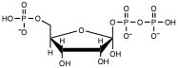
B) | 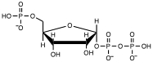
C) | 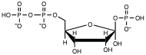
D) | 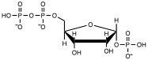
E) | none of the above

Answer: B

Difficulty: 2 Topic: PRPP

3) | What molecule contributes at least two nitrogen atoms to each purine?

A) | asparagine
B) | 10-formyltetrahydrofolate
C) | glycine
D) | glutamine
E) | carbamoyl phosphate

Answer: D

Difficulty: 1 Topic: De Novo Biosynthesis of Purine Nucleotides

4) | Which enzyme of the inosinic acid biosynthesis pathway is the major control point for purine synthesis?

A) | phosphoribosyl pyrophosphate amidotransferase
B) | glycinamide ribonucleotide transformylase
C) | formylglycinamidine ribonucleotide amidotransferase
D) | 5-aminoimidazole ribonucleotide synthetase
E) | 5-aminoimidazole ribonucleotide carboxylase

Answer: A

Difficulty: 1 Topic: De Novo Biosynthesis of Purine Nucleotides

5) | The ten enzyme activities that convert PRPP to inosinic acid are part of a multienzyme complex known as the _________.

A) | IMP synthetase complex
B) | purine synthetase complex
C) | purinosome
D) | tetrahydrofolate synthase complex
E) | none of the above

Answer: C

Difficulty: 1 Topic: De Novo Biosynthesis of Purine Nucleotides

6) | During the conversion of IMP to GMP and AMP, __________ serves as the nitrogen source for GMP, while _________ serves as the nitrogen source for AMP.

A) | glutamate, asparagine
B) | glutamate, aspartate
C) | glutamine, asparagine
D) | glutamine, aspartate
E) | none of the above

Answer: D

Difficulty: 2 Topic: De Novo Biosynthesis of Purine Nucleotides

7) | Which of the following coenzymes contains an adenylate group?

A) | cobalamin
B) | tetrahydrofolate
C) | thiamine pyrophosphate
D) | pyridoxal phosphate
E) | coenzyme A

Answer: E

Difficulty: 1 Topic: De Novo Biosynthesis of Purine Nucleotides

8) | Which of the following is a product of xanthine dehydrogenase?

A) | hypoxanthine
B) | uric acid
C) | guanine
D) | xanthosine
E) | allantoin

Answer: B

Difficulty: 1 Topic: Purine Degradation and Clinical Disorders of Purine Metabolism

9) | The following reaction is catalyzed by what enzyme?

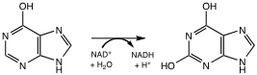

A) | xanthine oxidoreductase
B) | hypoxanthine hydroxylase
C) | urate oxidase
D) | guanine oxidase
E) | none of the above

Answer: A

Difficulty: 2 Topic: Purine Degradation and Clinical Disorders of Purine Metabolism

10) | Which of the following correctly explains the relationship between xanthine dehydrogenase (XDH) and xanthine oxidase (XO)?

A) | in healthy tissue, XDH is abundant while XO is rarely found
B) | conversion of XDH to XO occurs under conditions that damage cells
C) | XDH is converted to XO by formation of a disulfide bond
D) | XDH is converted to XO by proteolysis
E) | all of the above

Answer: E

Difficulty: 2 Topic: Purine Degradation and Clinical Disorders of Purine Metabolism

11) | What molecule(s) is(are) the source of the two nitrogen atoms for pyrimidine synthesis?

A) | asparagine
B) | glutamine, glutamate
C) | aspartate, carbamoyl phosphate
D) | carbamoyl phosphate, glutamine
E) | aspartate, glutamate

Answer: C

Difficulty: 2 Topic: Pyrimidine Nucleotide Metabolism

12) | Which enzyme of the pyrimidine synthesis pathway is the most highly regulated?

A) | carbamoyl phosphate synthetase
B) | aspartate transcarbamoylase
C) | orotate phosphoribosyltransferase
D) | UMP kinase
E) | nucleoside diphosphate kinase

Answer: B

Difficulty: 2 Topic: Pyrimidine Nucleotide Metabolism

13) | Which of the following sequence of events best explains the formation of carbamate in the mechanism of carbamoyl phosphate synthetase?

A) | Bicarbonate and ATP form carboxyphosphate, then NH₃ performs a nucleophilic attack on carboxyphosphate to form carbamate
B) | Bicarbonate is attacked by NH₃ to produce carbamate with ATP hydrolysis occurring solely to drive the reaction to completion
C) | Bicarbonate reacts with ATP forming carboxy adenylate and pyrophosphate, then NH₃ performs a nucleophilic attack on carboxy adenylate to form carbamate
D) | NH₃ reacts with ATP, which then reacts with bicarbonate followed by loss of phosphate to produce carbamate
E) | none of the above

Answer: A

Difficulty: 3 Topic: Pyrimidine Nucleotide Metabolism

14) | The end products of the pyrimidine catabolic pathway are ammonia, carbon dioxide and __________.

A) | asparagine
B) | aspartic acid
C) | dihydrouracil
D) | β-alanine
E) | glutamate

Answer: D

Difficulty: 1 Topic: Pyrimidine Nucleotide Metabolism
15) | Which of the following best explains the initial steps for the synthesis of deoxynucleotides?

A) | begins with reduction of the ribose residue in PRPP
B) | deoxy PRPP is formed from deoxyribose-5-phosphate
C) | formed by reduction of ribonucleotide counterparts
D) | formed by oxidation of ribonucleotide counterparts
E) | none of the above

Answer: C

Difficulty: 2 Topic: Deoxyribonucleotide Biosynthesis and Metabolism

16) | Which of the following best explains the enzyme(s) involved in ribonucleotide reduction?

A) | there is 1 enzyme for each of the 4 different nucleotides
B) | 1 enzyme for pyrimidine nucleotides and 1 for purine nucleotides
C) | 1 enzyme for pyrimidine nucleotides, 1 for ADP and 1 for GDP
D) | 1 enzyme for purine nucleotides, 1 for CDP and 1 for UDP
E) | 1 enzyme for all 4 nucleotides

Answer: E

Difficulty: 1 Topic: Deoxyribonucleotide Biosynthesis and Metabolism

17) | Which of the following correctly describes the activity or regulation of E coli ribonucleotide reductase?

A) | the overall activity of the enzyme is controlled by ATP and dATP
B) | the specificity of the enzyme is controlled by all four dNTPs
C) | a tyrosine free radical participates in the reaction
D) | the reduction is not a result of simple hydride transfer
E) | all of the above

Answer: E

Difficulty: 2 Topic: Deoxyribonucleotide Biosynthesis and Metabolism

18) | Which of the following shows the correct and complete flow of electrons for ribonucleotide reductase?

A) | NADH → FAD → thioredoxin → ribonucleotide reductase
B) | NADPH → glutathione → glutaredoxin → ribonucleotide reductase
C) | NADPH → thioredoxin → cytochrome-b → ribonucleotide reductase
D) | FADH₂ → glutathione → glutaredoxin → ribonucleotide reductase
E) | none of the above

Answer: B

Difficulty: 2 Topic: Deoxyribonucleotide Biosynthesis and Metabolism

19) | When ATP is bound in the activity site and ______ is bound in the specificity site, _______ will be reduced by ribonucleotide reductase.

A) | ATP; ADP and GDP
B) | dATP; GDP, UDP and CDP
C) | dTTP; GDP and ADP
D) | dGTP; ADP
E) | none of the above are correct

Answer: D

Difficulty: 3 Topic: Deoxyribonucleotide Biosynthesis and Metabolism

20) | Which of the following describes the coenzyme involved with thymidylate synthase?

A) | 5-methyl-THF serves as the methyl donor
B) | 10-methyl-THF serves as the methyl donor
C) | 5,10-methylene-THF serves as both methylene donor and reducing agent
D) | 5,10-methenyl-THF serves as both methylene donor and reducing agent
E) | S-adenosylmethionine serves as the methyl donor

Answer: C

Difficulty: 2 Topic: Deoxyribonucleotide Biosynthesis and Metabolism

21) | The following molecule is an irreversible inhibitor of which enzyme of nucleotide metabolism?

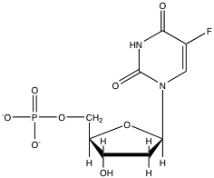

A) | ribonucleotide reductase
B) | thymidylate synthase
C) | thymidine kinase
D) | dCMP deaminase
E) | CTP synthetase

Answer: B

Difficulty: 2 Topic: Thymidylate Synthase

22) | The molecule below would be an analog of __________ and therefore an effective _________compound.

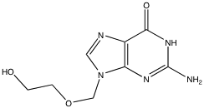

A) | adenosine; anticancer
B) | adenosine; antiviral
C) | guanosine; anticancer
D) | guanosine; antiviral
E) | none of the above

Answer: D

Difficulty: 2 Topic: Biological and Medical Importance of Nucleotide Analogs

Short Answer Questions

1) Given the structure of GMP, indicate the source for all carbons and nitrogens in the guanine base.

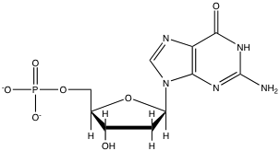

Answer:

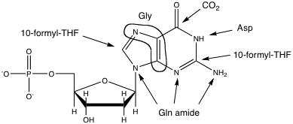

Difficulty: 3 Topic: De Novo Biosynthesis of Purine Nucleotides

2) Show the reaction of allopurinol with xanthine dehydrogenase and explain how this molecule functions as an inhibitor of the enzyme.

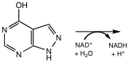

Answer:

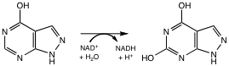

The product, alloxanthine, binds extremely tightly to the enzyme. Thus, allopurinol is a suicide substrate since once the enzyme acts upon it, it becomes almost permanently inhibited.

Difficulty: 2 Topic: Purine Degradation and Clinical Disorders of Purine Metabolism

3) Below is the structure of 3′-azido-2′,3′-dideoxythymidine (also known as AZT). Draw the structure of the metabolite of AZT that serves as the inhibitor of reverse transcriptase.

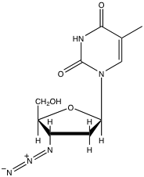

Answer:

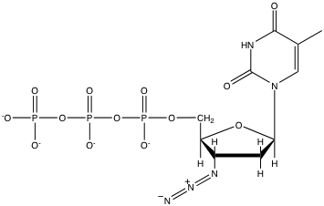

Difficulty: 2 Topic: Biological and Medical Importance of Nucleotide Analogs

